Asimov The Twelve Frights of Christmas, Avon Stated First Dec 1986, First print No dust jacket. Very good soffcover book with price $3.50 on cover. All 263 pages tightly bound with no marks. Some staining. ISBN 0380750988
We wish you a macabre Christmas with thirteen of the best horror tales of the season

ID 000276. Price $15 Box 4

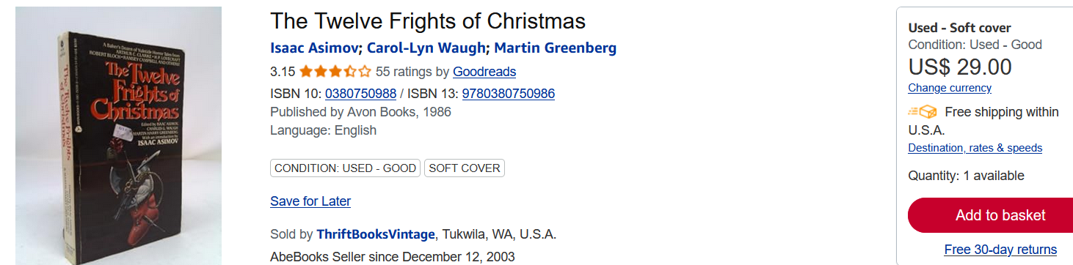
AbeBooks $7.40 to $29
Amazon $17
Ebay $40

ID 00027X Price $ Box 4

